UJIAN TENGAH SEMESTER

Kelompok : Capybaraa

Amggota kelompok:

1. Adistira Altafia A/03
2. Ghefira Nuris Sobah/15
3. Safirotul Muslimah/30

Bab 3: mebuat desain web berupa situs portal yang berisi bebrapa link ke mesin pencari

<!DOCTYPE *html*>

<html *lang*="id">

<head>

  <meta *charset*="utf-8" />

  <meta *name*="viewport" *content*="width=device-width, initial-scale=1" />

  <title>Portal Link - Mesin Pencari & Berita</title>

  <link *href*="https://cdn.jsdelivr.net/npm/bootstrap@5.3.2/dist/css/bootstrap.min.css" *rel*="stylesheet">

  <style>

    :root{

      --accent: #0d6efd;

    }

    body{background: #f8f9fa;}

    .search-card{border-radius:12px; box-shadow:0 6px 18px rgba(13,110,253,0.06);}

    .favicon{width:28px;height:28px;object-fit:contain}

    .site-card:hover{transform:translateY(-4px);transition:all .18s ease}

    .site-card{transition:all .18s ease}

    .dark-mode{background:#0b1220;color:#e9eef8}

    .dark-mode .card{background: #0f1724;color:#e9eef8}

    .toggle-btn{cursor:pointer}

  </style>

</head>

<body>

*<!-- Header -->*

  <nav *class*="navbar navbar-expand-lg navbar-light bg-white border-bottom">

    <div *class*="container">

      <a *class*="navbar-brand fw-bold" *href*="#">Portal Link</a>

      <div *class*="d-flex align-items-center">

        <button *id*="themeToggle" *class*="btn btn-outline-secondary btn-sm me-2 toggle-btn">Dark</button>

        <a *class*="btn btn-primary btn-sm" *href*="#links">Lihat Link</a>

      </div>

    </div>

  </nav>

*<!-- Hero / Search -->*

  <header *class*="container py-5">

    <div *class*="row justify-content-center">

      <div *class*="col-lg-8">

        <div *class*="card p-4 search-card">

          <h3 *class*="mb-2">Cari apa hari ini?</h3>

          <p *class*="text-muted small">Pilih mesin pencari lalu ketik kata kunci. Hasil akan terbuka di tab baru.</p>

          <div *class*="row g-2 align-items-center">

            <div *class*="col-md-8">

              <input *id*="q" *type*="search" *class*="form-control form-control-lg" *placeholder*="Contoh: pendidikan online, berita teknologi" *aria-label*="query">

            </div>

            <div *class*="col-md-4 d-flex">

              <select *id*="engine" *class*="form-select me-2">

                <option *value*="https://www.google.com/search?q=%s">Google</option>

                <option *value*="https://www.bing.com/search?q=%s">Bing</option>

                <option *value*="https://search.yahoo.com/search?p=%s">Yahoo</option>

                <option *value*="https://duckduckgo.com/?q=%s">DuckDuckGo</option>

              </select>

              <button *id*="searchBtn" *class*="btn btn-primary">Cari</button>

            </div>

          </div>

          <div *class*="mt-3 small text-muted">Shortcut: tekan Enter untuk cari. Hasil terbuka di tab baru.</div>

        </div>

      </div>

    </div>

  </header>

*<!-- Links Section -->*

  <main *class*="container mb-5" *id*="links">

    <div *class*="row g-4">

*<!-- Search Engines -->*

      <div *class*="col-lg-6">

        <h5 *class*="mb-3">Mesin Pencari</h5>

        <div *class*="row row-cols-1 row-cols-md-2 g-3">

*<!-- Card item -->*

          <div *class*="col">

            <a *class*="text-decoration-none" *href*="https://www.google.com" *target*="_blank">

              <div *class*="card p-3 site-card">

                <div *class*="d-flex align-items-center">

                  <img *class*="favicon me-3" *src*="https://www.google.com/favicon.ico" *alt*="Google">

                  <div>

                    <div *class*="fw-semibold">Google</div>

                    <div *class*="small text-muted">Pencarian umum & berita</div>

                  </div>

                </div>

              </div>

            </a>

          </div>

          <div *class*="col">

            <a *class*="text-decoration-none" *href*="https://www.bing.com" *target*="_blank">

              <div *class*="card p-3 site-card">

                <div *class*="d-flex align-items-center">

                  <img *class*="favicon me-3" *src*="https://www.bing.com/sa/simg/favicon-2x.ico" *alt*="Bing">

                  <div>

                    <div *class*="fw-semibold">Bing</div>

                    <div *class*="small text-muted">Pencarian & gambar</div>

                  </div>

                </div>

              </div>

            </a>

          </div>

          <div *class*="col">

            <a *class*="text-decoration-none" *href*="https://duckduckgo.com" *target*="_blank">

              <div *class*="card p-3 site-card">

                <div *class*="d-flex align-items-center">

                  <img *class*="favicon me-3" *src*="https://duckduckgo.com/favicon.ico" *alt*="DuckDuckGo">

                  <div>

                    <div *class*="fw-semibold">DuckDuckGo</div>

                    <div *class*="small text-muted">Pencarian privasi</div>

                  </div>

                </div>

              </div>

            </a>

          </div>

          <div *class*="col">

            <a *class*="text-decoration-none" *href*="https://search.yahoo.com" *target*="_blank">

              <div *class*="card p-3 site-card">

                <div *class*="d-flex align-items-center">

                  <img *class*="favicon me-3" *src*="https://s.yimg.com/rz/l/favicon.ico" *alt*="Yahoo">

                  <div>

                    <div *class*="fw-semibold">Yahoo</div>

                    <div *class*="small text-muted">Pencarian & portal berita</div>

                  </div>

                </div>

              </div>

            </a>

          </div>

        </div>

      </div>

*<!-- News Links -->*

      <div *class*="col-lg-6">

        <h5 *class*="mb-3">Portal Berita</h5>

        <div *class*="row row-cols-1 g-3">

          <div *class*="col">

            <div *class*="card p-3">

              <div *class*="d-flex align-items-center">

                <img *class*="favicon me-3" *src*="https://detik.com/favicon.ico" *alt*="Detik" *onerror*="**this**.src='https:*//picsum.photos/32'*">

                <div>

                  <a *class*="fw-semibold d-block text-decoration-none" *href*="https://www.detik.com" *target*="_blank">Detik</a>

                  <div *class*="small text-muted">Berita terkini Indonesia</div>

                </div>

              </div>

            </div>

          </div>

          <div *class*="col">

            <div *class*="card p-3">

              <div *class*="d-flex align-items-center">

                <img *class*="favicon me-3" *src*="https://kompas.com/favicon.ico" *alt*="Kompas" *onerror*="**this**.src='https:*//picsum.photos/32'*">

                <div>

                  <a *class*="fw-semibold d-block text-decoration-none" *href*="https://www.kompas.com" *target*="_blank">Kompas</a>

                  <div *class*="small text-muted">Liputan mendalam & opini</div>

                </div>

              </div>

            </div>

          </div>

          <div *class*="col">

            <div *class*="card p-3">

              <div *class*="d-flex align-items-center">

                <img *class*="favicon me-3" *src*="https://www.bbc.com/favicon.ico" *alt*="BBC">

                <div>

                  <a *class*="fw-semibold d-block text-decoration-none" *href*="https://www.bbc.com" *target*="_blank">BBC</a>

                  <div *class*="small text-muted">Berita internasional</div>

                </div>

              </div>

            </div>

          </div>

          <div *class*="col">

            <div *class*="card p-3">

              <div *class*="d-flex align-items-center">

                <img *class*="favicon me-3" *src*="https://www.cnnindonesia.com/assets/images/favicon.ico" *alt*="CNN">

                <div>

                  <a *class*="fw-semibold d-block text-decoration-none" *href*="https://www.cnnindonesia.com" *target*="_blank">CNN Indonesia</a>

                  <div *class*="small text-muted">Berita & analisis</div>

                </div>

              </div>

            </div>

          </div>

        </div>

      </div>

    </div>

*<!-- Quick Links / Categories -->*

    <div *class*="mt-4">

      <h6>Kategori Cepat</h6>

      <div *class*="d-flex flex-wrap gap-2 mt-2">

        <a *class*="btn btn-outline-secondary btn-sm" *href*="https://news.google.com" *target*="_blank">Berita Lokal</a>

        <a *class*="btn btn-outline-secondary btn-sm" *href*="https://news.google.com/topics/CAAqJggKIiBDQkFTRWdvSUwyMHZNRFZxYUdjU0FtVnVHZ0pKQVAB" *target*="_blank">Teknologi</a>

        <a *class*="btn btn-outline-secondary btn-sm" *href*="https://news.google.com/topics/CAAqJggKIiBDQkFTRWdvSUwyMHZNRFp6YUdjU0FtVnVHZ0pKQVAB" *target*="_blank">Olahraga</a>

        <a *class*="btn btn-outline-secondary btn-sm" *href*="https://finance.yahoo.com" *target*="_blank">Ekonomi</a>

      </div>

    </div>

  </main>

*<!-- Footer -->*

  <footer *class*="bg-white border-top py-3">

    <div *class*="container d-flex justify-content-between small">

      <div>&copy; 2025 Portal Link</div>

      <div>Made for tugas sekolah • <a *href*="#" *class*="text-decoration-none">Privacy</a></div>

    </div>

  </footer>

  <script>

*// Search behaviour: replace %s with encoded query and open in new tab*

    const searchBtn = document.getElementById('searchBtn');

    const qInput = document.getElementById('q');

    const engineSelect = document.getElementById('engine');

    function doSearch(){

      const q = encodeURIComponent(qInput.value.trim());

      if(!q) return qInput.focus();

      const template = engineSelect.value;

      const url = template.replace('%s', q);

      window.open(url, '_blank');

    }

    searchBtn.addEventListener('click', doSearch);

    qInput.addEventListener('keydown', (*e*)=>{ if(*e*.key === 'Enter') doSearch(); });

*// Dark mode toggle (simple)*

    const themeToggle = document.getElementById('themeToggle');

    themeToggle.addEventListener('click', ()=>{

      document.body.classList.toggle('dark-mode');

      themeToggle.textContent = document.body.classList.contains('dark-mode') ? 'Light' : 'Dark';

    });

  </script>

  <script *src*="https://cdn.jsdelivr.net/npm/bootstrap@5.3.2/dist/js/bootstrap.bundle.min.js"></script>

</body>

</html>

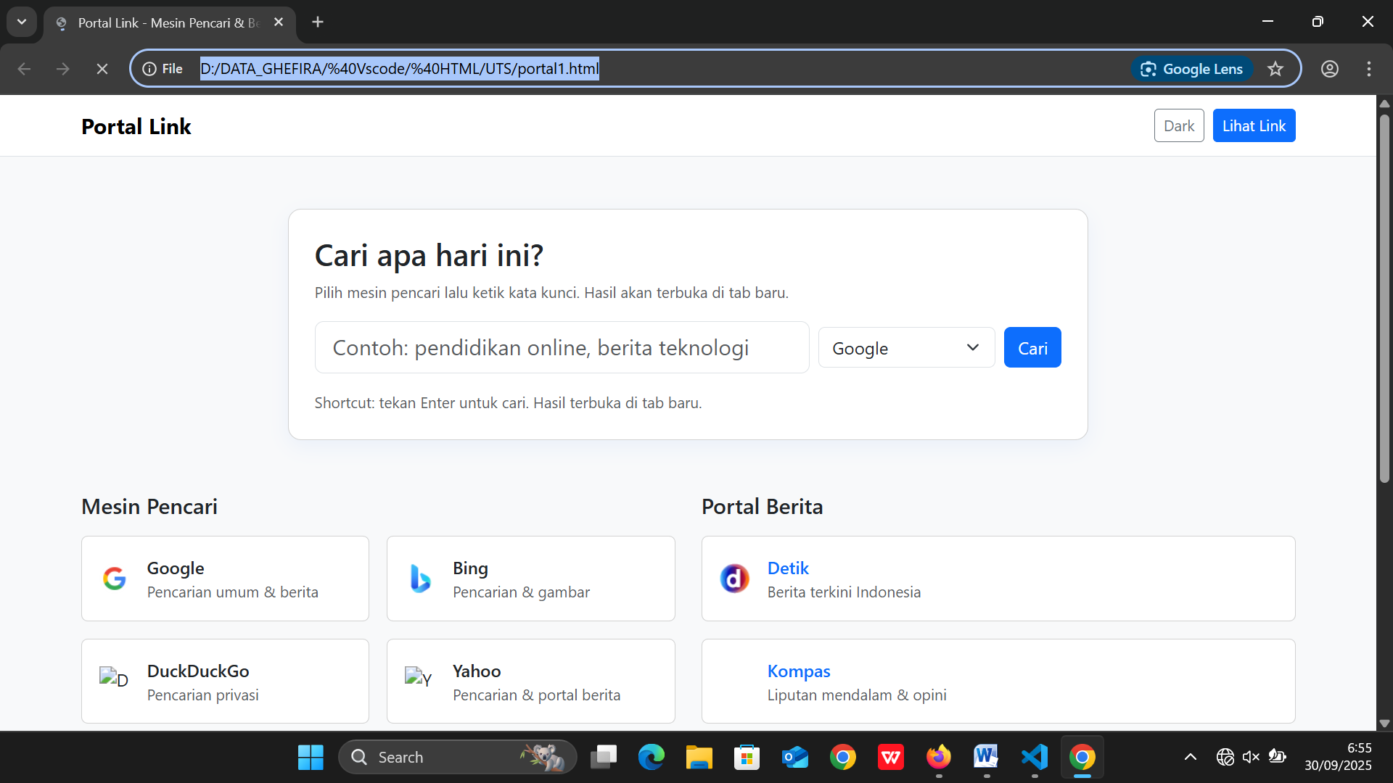

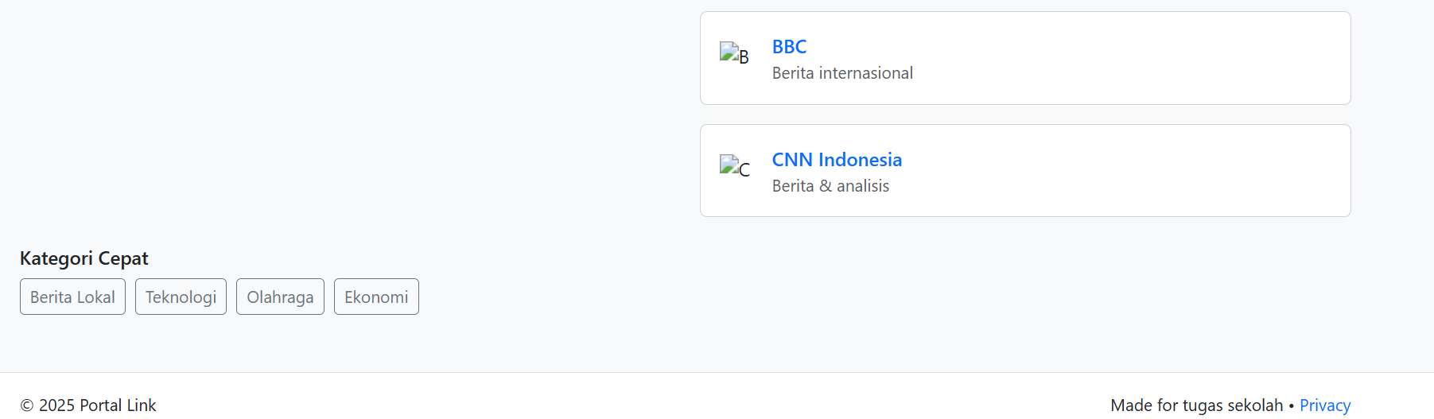

Bab 4: Membuat rekaman suara anggota kelompok dalam format mp3

<!DOCTYPE *html*>

<html>

<head>

  <title>Memutar Audio</title>

</head>

<body>

  <h2>Rekaman Suara Kelompok Kami</h2>

*<!-- Menampilkan audio -->*

  <audio *controls*>

    <source *src*="WhatsApp Audio 2025-09-29 at 6.12.41 PM.mp4" *type*="audio/mpeg">

    Browser kamu tidak mendukung pemutar audio.

  </audio>

</body>

</html>